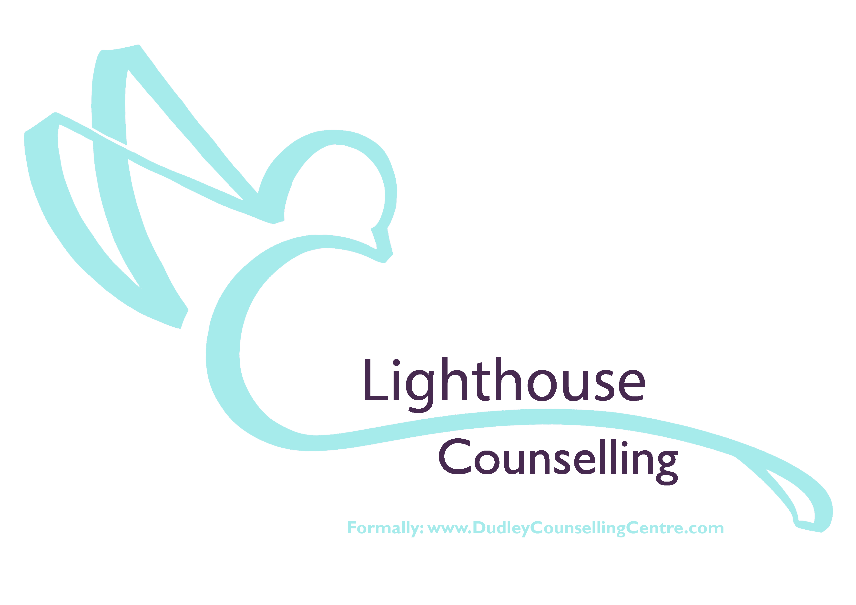
Relationship / Couples Counselling Referral

Please complete all fields in the following form, you can email or post back to Lighthouse Counselling.

Please include information of both parties

Title | Title
Forename | Forename
Surname | Surname
Date of Birth | Date of Birth
Address | Address (if different)
Postcode | Postcode
Main Contact Numbers | Main Contact Numbers
Can we leave messages?  Yes No | Can we leave messages?  Yes No
Your Email | Your Email
Employment Status | Employment Status
Gender | Gender
Ethnicity | Ethnicity
Religion (if none, enter 'none') | Religion (if none, enter 'none')
Relationship Status | Relationship Status
Length of relationship
Any dependent(s) of this relationship / previous relationship:

Do you have a disability we should take into account when allocating appointment premises? (required) Yes / No | Do you have a disability we should take into account when allocating appointment premises? (required) Yes / No
YOUR CURRENT DIFFICULTIES
Please give any further details that you feel would help us understand your current problem?

What would you like to achieve within the Relationship / Couples counselling sessions?

I give consent for the above information to be used in assessment.

Sign…………………………………..….. Date …………………………

Your completed form will be assessed by a qualified counsellor, who will contact regarding the next step in our process of counselling provision.

Should you have any questions please feel free to get in touch either by email; admin@lighthousecounselling.org or telephone 01384 239222.

You can return the completed form via email to admin@lighthousecounselling.org

Post or deliver by hand to;
The Lighthouse Centre
Lighthouse Counselling
Salop Street,
Dudley, DY1 3AT

