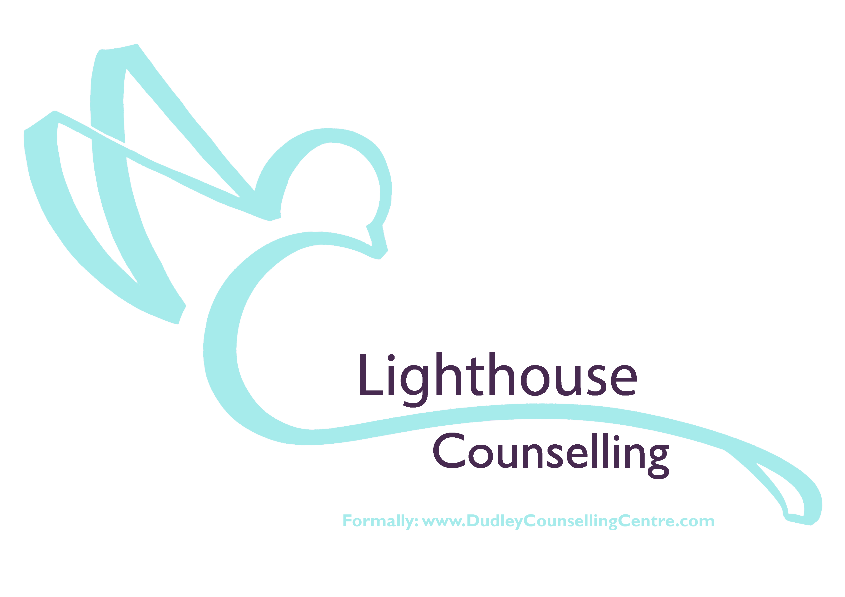
Adult Self-Referral

This form is used during the COVID-19 period only. Please complete all fields in the following form and email to admin@lighthousecounselling.org or post it to us.

Referral Date

Where did you hear from us (Radio/Facebook/Website/others…)

Title

Forename

Surname

Date of Birth

Address

Postcode

Main Contact Number

Can we leave messages? Yes No

Your Email

Employment Status

Gender

Ethnicity

Religion (if none, enter 'none')

Relationship Status

Do you have a disability we should take into account when allocating appointment premises? (required) Yes / No

Does your doctor know you are contacting us? Yes / No

YOUR CURRENT DIFFICULTIES

Please give any further details that you feel would help us understand your current problem?
Please enter simple bullet points:

Terms & Conditions

During Covid-19 period, two free telephone counselling sessions lasting 30-50 minutes will be offered. The second follow up call will be one week later following the initial when considered appropriate and agreed.

We aim to support clients who are experiencing anxiety or mental health issues, we are offering some solution focused coping mechanisms to support mental or emotional well-being, signposting and offering prayer support when requested.

Personal crisis procedures. We cannot provide an emergency service for clients. If you find yourself in a major crisis and were considering serious self-harm it would be vital to get immediate help. Please contact the Samaritans free on 116 123 or email jo@samaritans.org or if under 35, call free: 0800 068 41 41,
text 07860 039967 or email pat@papyrus-uk.org or call your nearest accident and emergency department (A & E) on 111.

Your completed form will be assessed by a qualified counsellor, who will contact you regarding the next step in our process of counselling provision.

Sign…………………………………………... Date …………………………………..…

Should you have any questions please feel free to get in touch either by email; admin@lighthousecounselling.org or telephone 01384 239222.

Post or deliver by hand to;
Lighthouse Counselling (Formerly Dudley Counselling Centre)
C/O Dudley Community Church
Salop Street
Dudley
DY1 3AT

